USN | 1 | M | S
M S RAMAIAH INSTITUTE OF TECHNOLOGY
(AUTONOMOUS INSTITUTE, AFFILIATED TO VTU)
BANGALORE – 560 054
MAKE UP EXAMINATIONS – JUNE/JULY 2016

Course & Branch | : | B.E. - Common to All Branches | Semester | : | II
Subject | : | Engineering Mathematics –II | Max. Marks | : | 100
Subject Code | : | MAT201 | Duration | : | 3 Hrs

Instructions to the Candidates:
- Answer one full question from each unit.

 |  | UNIT – I
1. | a) | Write the derivative of arc length of a curve in polar form. | CO1 | (02)
 | b) | Using Maclaurin’s series expand 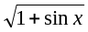 upto the term containing 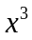. | CO1 | (03)
 | c) | Obtain the expression for radius of curvature in Cartesian form. | CO1 | (08)
 | d) | Show that the volume of the greatest parallelopipped that can be inscribed in the ellipsoid is 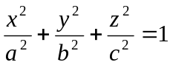 is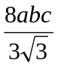 | CO1 | (07)
2. | a) | Define stationary point and saddle point. | CO1 | (02)
 | b) | If 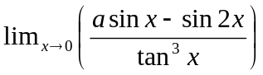 be finite, then find the value of ‘’ and the limit. | CO1 | (03)
 | c) | If 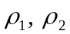 be the radii of curvature at the extremities of any chord  of the cardioids 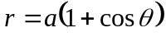 which passes through the pole  then show that 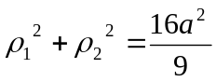 | CO1 | (08)
 | d) | Expand 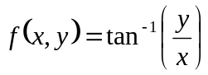 in powers of 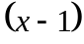 and 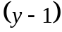 up  to the third degree terms. | CO1 | (07)
 |  | UNIT-II
3. | a) | Find the exact differential equation 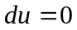when 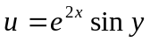 | CO2 | (02)
 | b) | The equation of an L-R circuit is given by 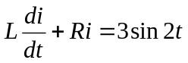 . If at  express as a function of if 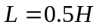 and 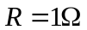. | CO2 | (03)
 | c) | Show that the family of curves 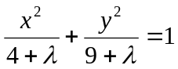 is self orthogonal, where is the parameter. | CO2 | (08)
 | d) | Suppose that an object is heated to 200⁰ F and allowed to cool in a room whose air temperature is 70⁰ F. After 10 minutes the temperature of the object is 145⁰ F. What will be its temperature after 25 minutes? | CO2 | (07)
4. | a) | Write Clairaut’s Equation and also give its solution. | CO2 | (02)
 | b) | Solve: 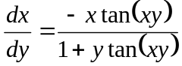. | CO2 | (03)
 | c) | Test for self orthogonality of 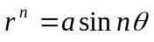 where is the parameter. | CO2 | (08)
 | d) | Solve: 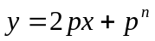 by the method of solvable for . | CO2 | (07)
 |  | UNIT – III
5. | a) | Define Initial and boundary conditions. | CO3 | (02)
 | b) | If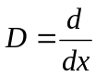and then prove that , where a is a constant. | CO3 | (03)
 | c) | A particle moves along the x-axis according to law 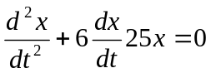. If the particle started at with an initial velocity of 12feet/sec to the left, determine x in terms of t. | CO3 | (08)
 | d) | Solve : 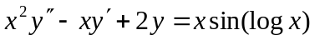 | CO3 | (07)
6. | a) | Write the Legendre’s LDE. | CO3 | (02)
 | b) | Solve : 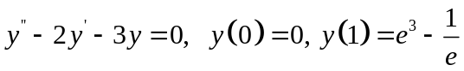 | CO3 | (03)
 | c) | Solve the differential equation 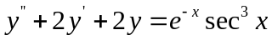 by the method of variation of parameters. | CO3 | (08)
 | d) | Solve 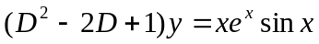 | CO3 | (07)
 |  | UNIT – IV
7. | a) | Define Gamma function. | CO4 | (02)
 | b) | If 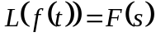 then prove that 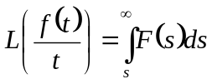 | CO4 | (03)
 | c) | Express the following function in terms of the Heaviside function and hence find its Laplace transform 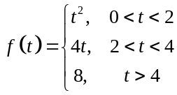 | CO4 | (08)
 | d) | Evaluate the following:  - 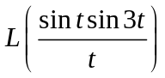 ii) | CO4 | (07)
8. | a) | Define unit step function and represent graphically. | CO4 | (02)
 | b) | If then prove that 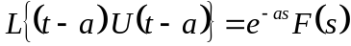 | CO4 | (03)
 | c) | Prove that: 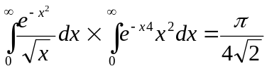 | CO4 | (08)
 | d) | Find: 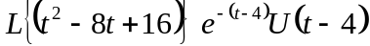. | CO4 | (07)
 |  | UNIT – V
9. | a) | Draw the graph of the periodic function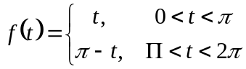 | CO5 | (02)
 | b) | Find the inverse Laplace transform of 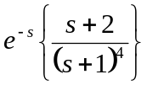 | CO5 | (03)
 | c) | In a circuit there is no energy stored and no current flowing prior to the closing of the switch at time =0. Determine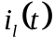 for 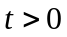for a constant applied voltage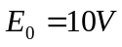.  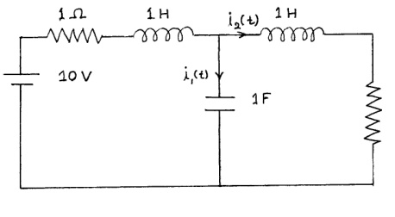 | CO5 | (08)
 | d) | Apply convolution theorem to evaluate.  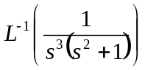. | CO5 | (07)
10. | a) | Find the inverse Laplace transform of 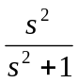 | CO5 | (02)
 | b) | Find the inverse Laplace Transform of the function. | CO5 | (03)
 | c) | Obtain the Laplace transform of the rectangular wave 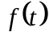 given by following figure.  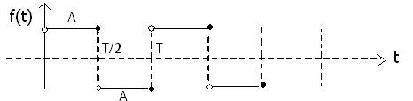 | CO5 | (08)
 | d) | Find the Inverse Laplace transform of:  - 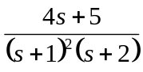 | CO5 | (07)

**********************

